2021 WORLD ROOKIE FEST PORTUGAL
Septembre, 25th SLX-Benedita Skate, Learn and Experience, Portugal
- REGISTRATIONS ARE OPEN -

Brand new SLX Benedita, Skate, Learn and Experience Skate School will be hosting one of the 10 stop opportunities to be qualified for the great World Rookie Tour Final in Innsbruck, Austria, where you can run for a ticket participation to Simple Session and to Mystic Skate Cup!

The ride is on. Portugal is one of the next stops where you can conquer the opportunity to run in Austria at the great final of the World Rookie Tour Skateboarding for some incredible prizes such as invitations to some of the most prestigious world wide skate competitions as Simple Session and the Mystic Skate Cup.
Registrations are now open. Portugal’s stop will be held at SLX Benedita, Skate, Learn and Experience Skate Park, on the 25th of September, where riders will also be invited to experience some of the workshops held at the school, such as screen printing, stencil painting and many others.
Rookie Fest Portugal’s participants and winners will also receive many other gigs and prizes offered by our tour sponsors Screw Skateboards, Ericeira Surf and Skate, TSG, Jail Jam, Blue Tomato.

If you are skater and if your dream is to start a professional carrier, you don’t want to miss this opportunity!

Download here the event info, program and registration form

IMPORTANT: QUALIFYING CRITERIA TO THE 2021 WORLD ROOKIE FEST SKATEBOARDING
- Riders, male and female, born 1st January 2000 and younger are admitted.
- Riders will be divided in 2 age groups: born before/after 2006.
Registration, info and bookings:
registration@worldrookietour.com
On location registration 25^{th, from 09:30 to 12:30}
Max. 60 Riders – first come, first served

2021 World Rookie Tour Skateboard Calendar
Hamburg - Germany - 18-19 June
Higashi Osaka - Japan - 18 July
Budapest - Hungary - 14-15 August
Chemnitz - Germany - 3-5 September
Winterthur - Switzerland - 10-11 September
Glasgow - Scotland - 11-12 September
Sofia - Bulgaria - 17-19 September
Prague - Czech Republic - 24- 26 September
Benedita - Portugal - 25 September
Modena - Italy - 25-26 September
Innsbruck – Austria- World Rookie Tour Finals – 1-3 October

Follow the World Rookie Tour
Web: www.worldrookietour.com and www.wcsk8.com
Facebook: www.facebook.com/worldrookietour
Instagram: www.instagram.com/worldrookietour @worldrookietour #worldrookietour
Vimeo: www.vimeo.com/channels/worldrookietour
email: info@worldrookietour.com

The World Rookie Tour is organized by the Black Yeti ssrl in collaboration with World Cup of Skateboarding and selected independent organizers.

EVENT INFO

Event World Rookie Fest Benedita

Location SLX Benedita – Skate, Learn and Experience
Adress for Navi – Rua dr. Francisco Sá Carneiro, nº3,
2475 – 147 Benedita
https://www.instagram.com/slxbenedita/

SLX Benedita
Skate, Learn and Experience
Skatepark Photos

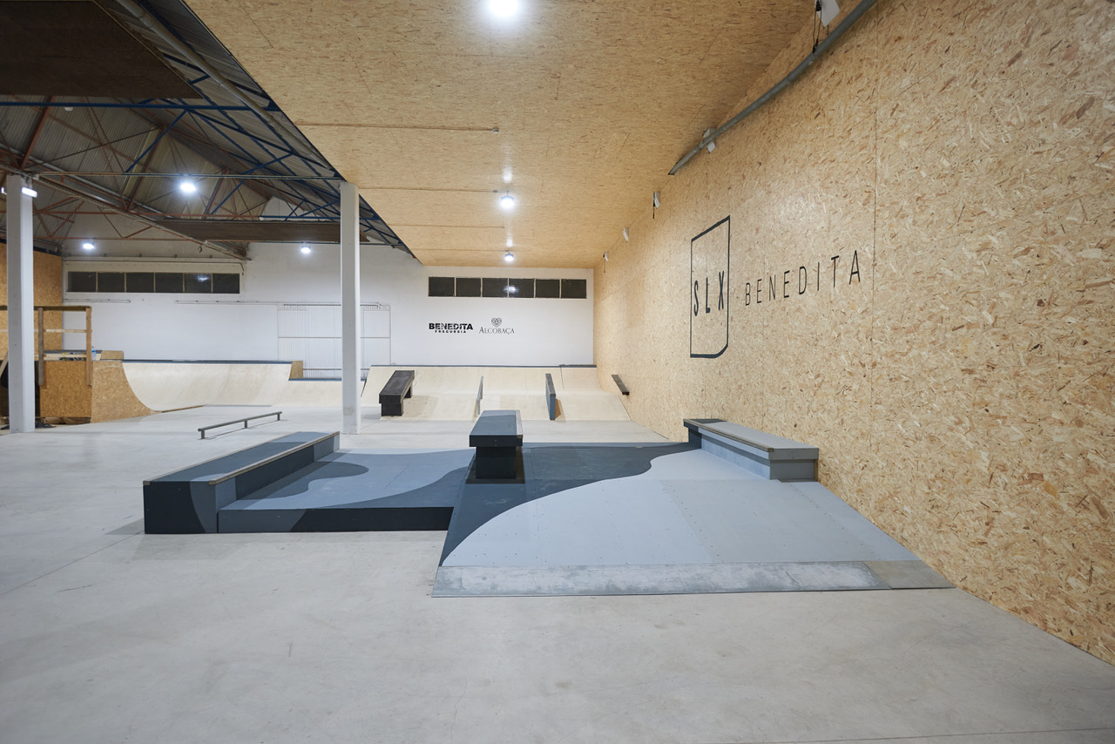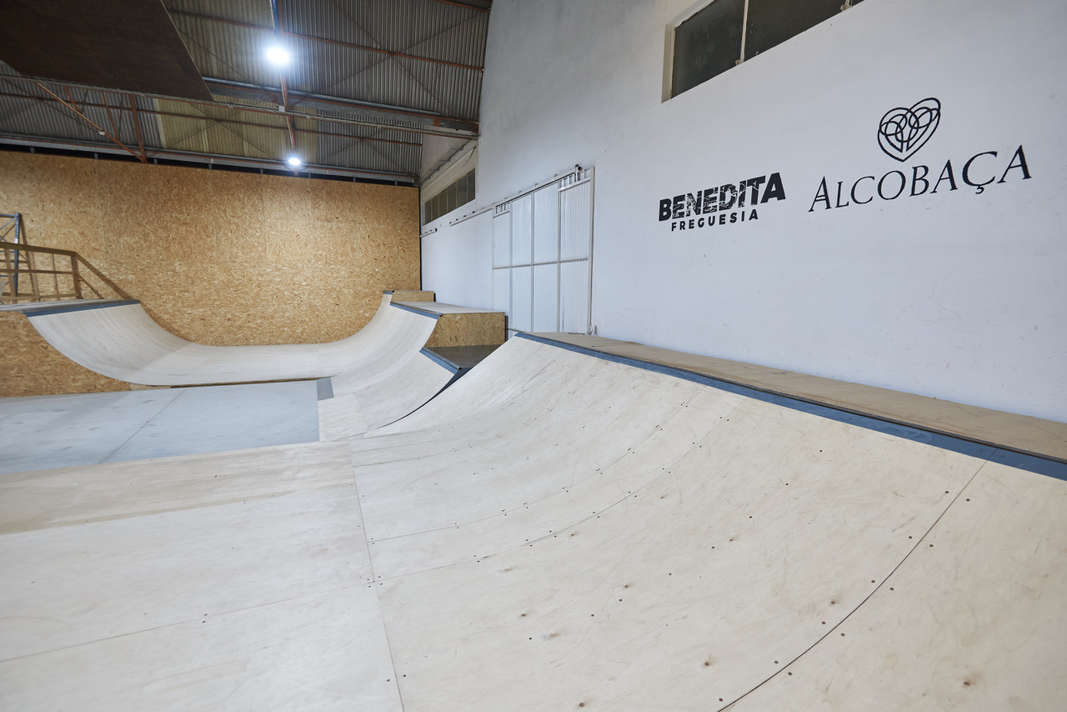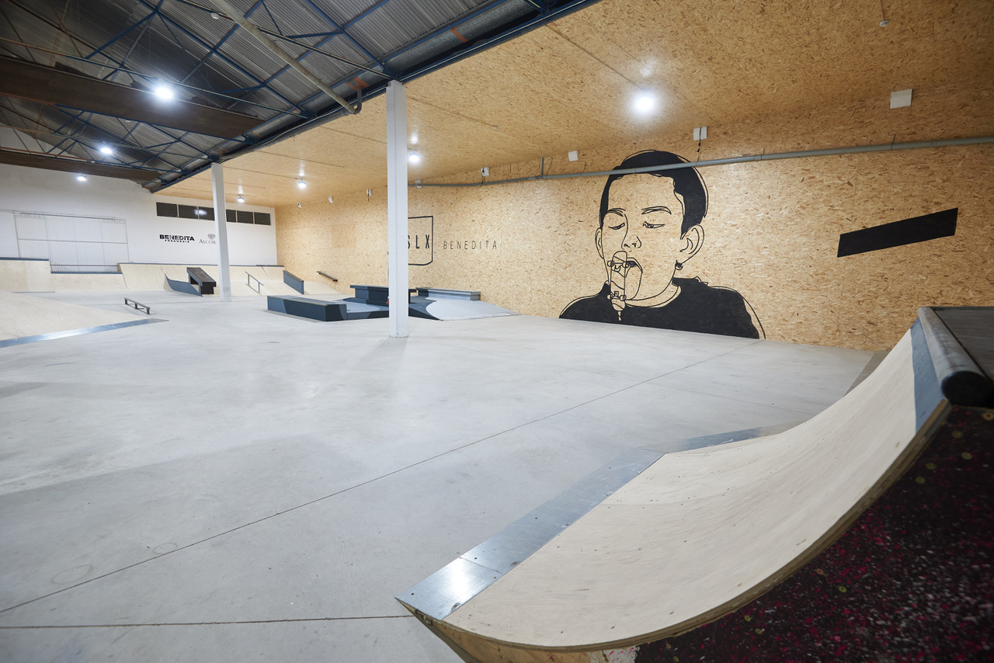

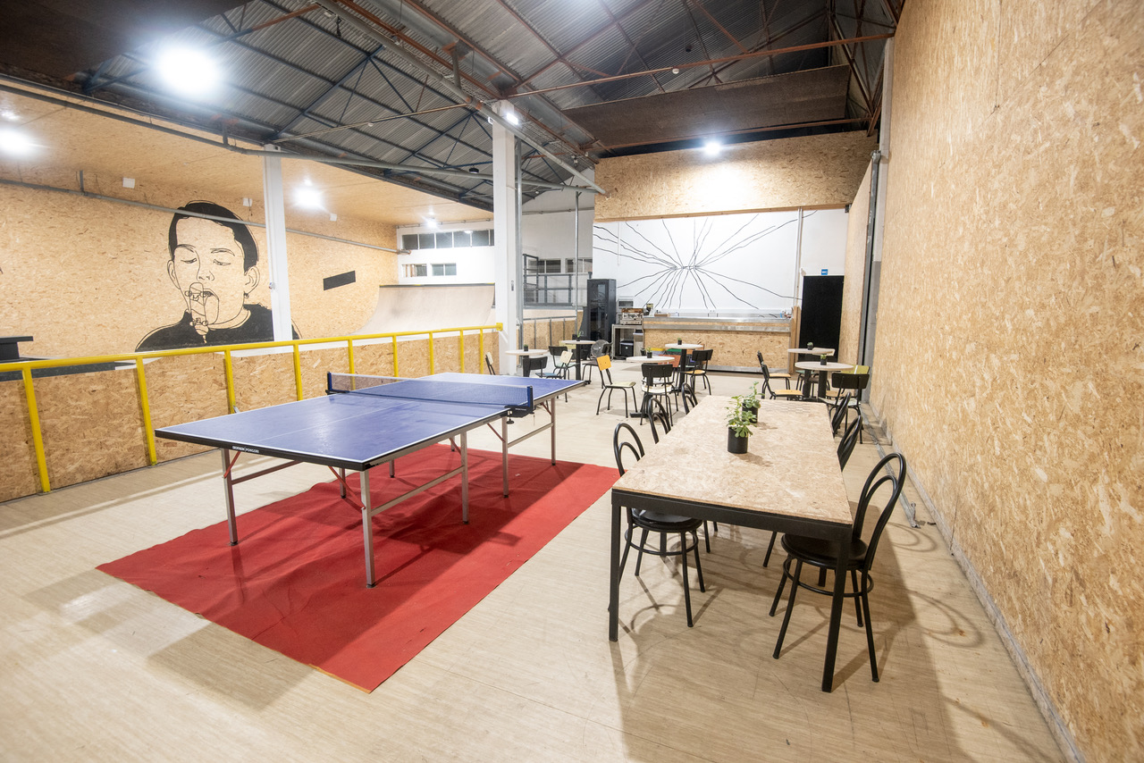

Riders Office SLX Benedita – Skate, Learn and Experience
Adress for Navi – Rua dr. Francisco Sá Carneiro, nº3,
2475 – 147 Benedita
NB: EVERYBODY AS WELL THE PREREGISTRATED RIDERS HAVE TO DO THE INSCRIPTION

Date Sept. 25th,. 2021

Event format Street – World Cup Skateboarding Event
Depends on amount of riders, to be announced at riders meeting o location
max 60 Riders – first come first served

Age groups Rookie (born from 2000 until 2005) and Grom (born 2006 and younger)

Prize Qualification Prizes from Screw Skateboards, Ericeira Surf & Skate, TSG, Blue Tomato and Jail Jam

Registrations Pre Registration: By returning the registration form attached to registration@worldrookietour.com before 23.09.2021
@MarcoNOTE: USE ROOKIE TOUR REGISTRATION

On Location Registration:
Saturday 25.09.2021 09:30 GMT to 11:00 GMT at the Riders Office

Entry fee 10€ with Pre Registration
15€ without Pre Registration (on location registration)

Judging Will be accomplished by official judges and sk8 experts.

TV Production & Pics: contact registration@worldrookietour.com
silvia@surgeskateboard.com

Sponsors & Partners: Red Bull, TSG, Blue Tomato, Jail Jam, IPDJ, #BeActive, Screw Skateboards, Ericeira Surf & Skate, Junta de Freguesia de Benedita, Entre Mercúrio e Marte

Media Sponsors Surge Skateboard Magazine, 4Media, Boardriding.com, Fuel Tv

Organization Zonasolta – Sport Association, Entre Mercúrio e Marte – Out of this World Productions,

Contact Persons Silvia Ferreira: silvia@surgeskateoard.com | (+351) 96 53 90 189

Official website www.worldrookietour.com

If you dream to become a professional action sport rider
then your future starts at the World Rookie Tour!

ABOUT THE WORLD ROOKIE TOUR
Organized by the Black Yeti ssrl in collaboration with International and National Sports Associations, it consists of a selection of high quality international events, in snowboard, freeski and skateboard, the so-called “Rookie Fests”, reserved for riders under 18/21, with stops in Europe, North and South America, Oceania and Asia. The World Rookie Tour consists not only of competitions: it also features loads of other activities to help rookies to grow in the field of professional snowboarding, such as photo & video shootings, avalanche and rescue clinics, meetings with photographers and international team managers, parties and English talks. Since year zero, it awards tickets to world-class events such as The Arctic Challenge, The Air & Style, the X Games, the Audi Nines, Red Bull Roller Coaster, Simple Session, Mystic Cup, invitations to professional snowboard photo & video shootings, and freeride trip in Chile. Every year the tour crowns the World Rookie Champion at the end of season, at the World Rookie Finals, a unique event where the best youngsters from almost 30 countries compete and have fun. More information at www.worldrookietour.com.
ABOUT BLACK YETI ssd
The Black Yeti is an amateur sport club dedicated to the realization of snowboard, freeski and skateboard projects for boys and girls up to 18 years of age, in Italy and abroad. One of the most successful project is the World Rookie Tour, the biggest and the most famous tour in the action sports world that attracts 2.000 young athletes from 30 nations to the events called “Rookie Fest”, organized all over the world: Italy, Europe, North and South America, Oceania and Asia. The Rookie Fests program includes not only the competition but also many side activities such as avalanche and rescue clinics, workshops and English talks.
World Rookie Tour Media Manager
Marco Sampaoli - marco@moonsrl.it - Phone +39.059.9783397 or +39.340.328.55.69
World Rookie Tour Event Coordinator
Meinhard Trojer - meinhardtrojer@powdern.com - Phone +43.650.56.37.424

World Rookie Tour Portugal Local Contact
Sílvia Ferreira (+351) 96 53 90 189 silvia@surgeskateboard.com

PROGRAM

Saturday, September, 25th, 2021
09:30 - 11:00 | Registration
09:30 - 13:00 | Free training at SLX Benedita – Skate, Learn and Experience
13:00 - 16:00 | Qualifications (max 60 Riders – first come first served)
16:00 - 18:00 | Print Screen Workshop/ Stencil Workshop
16:30 – 18:30 | Finals
18:30 | Best Trick
19:00 | Prize Giving
17:30 | Chill and Grill
18:00-20:00 | Sunset Chill @skateparque

THE PROGRAM CAN CHANGE DUE TO WEATHER, CONDITIONS AND AMOUNT OF RIDERS

CONTACTS

For general info
Meinhard Trojer - meinhardtrojer@powdern.com - mobile: +43 650 56 37 424

For media info
Marco Sampaoli - marco@moonsrl.it - Phone +39.059.9783397 or +39.340.328.55.69
For registration and hotel booking: registration@worldrookietour.com

World Rookie Tour Portugal Local Contact
Sílvia Ferreira (+351) 96 53 90 189 silvia@surgeskateboard.com

PRE-REGISTRATION FORM – Please Fill Out the Form Entirely

Coach-Parents Registration
Name of National Association / club
Name of coach/team manager

Mail & Mobile Phone of coach
How many people need accommodation?

Arrival Date |  |  |  |  | Departure Date

Skater registration and information (for each rider)
 | Last Name |  | First Name | Gender (M/F) |  | Birthday (mm/dd/yy) |  | E-Mail | Mobile
1st rider
2nd rider
3rd rider
4th rider
5th rider
6th rider
…
Crew
…
…
…

MEDIA ACCREDITATION FORM

Media Accreditation Request
Media Name

Media Type (Print, Radio TV, On-line)
Country

First Name |  |  | Last Name
E-Mail |  |  | Mobile

